Lab # 7 — Assessment Worksheet

**Course Name and Number: FRS301**

**Student Name: Tran Thanh Tuan**

**Student Id: SE161095**

**Instructor Name: Nguyen Van Vinh**

**Thumbnail cache**

***Creating Two Test Images***

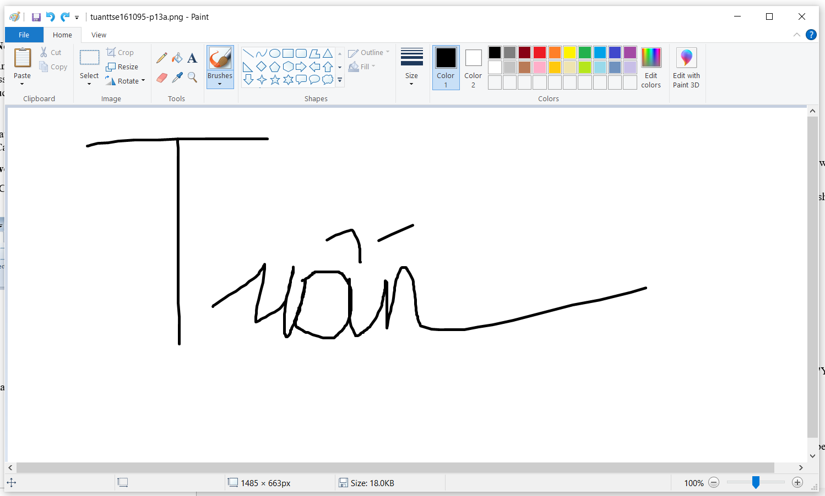

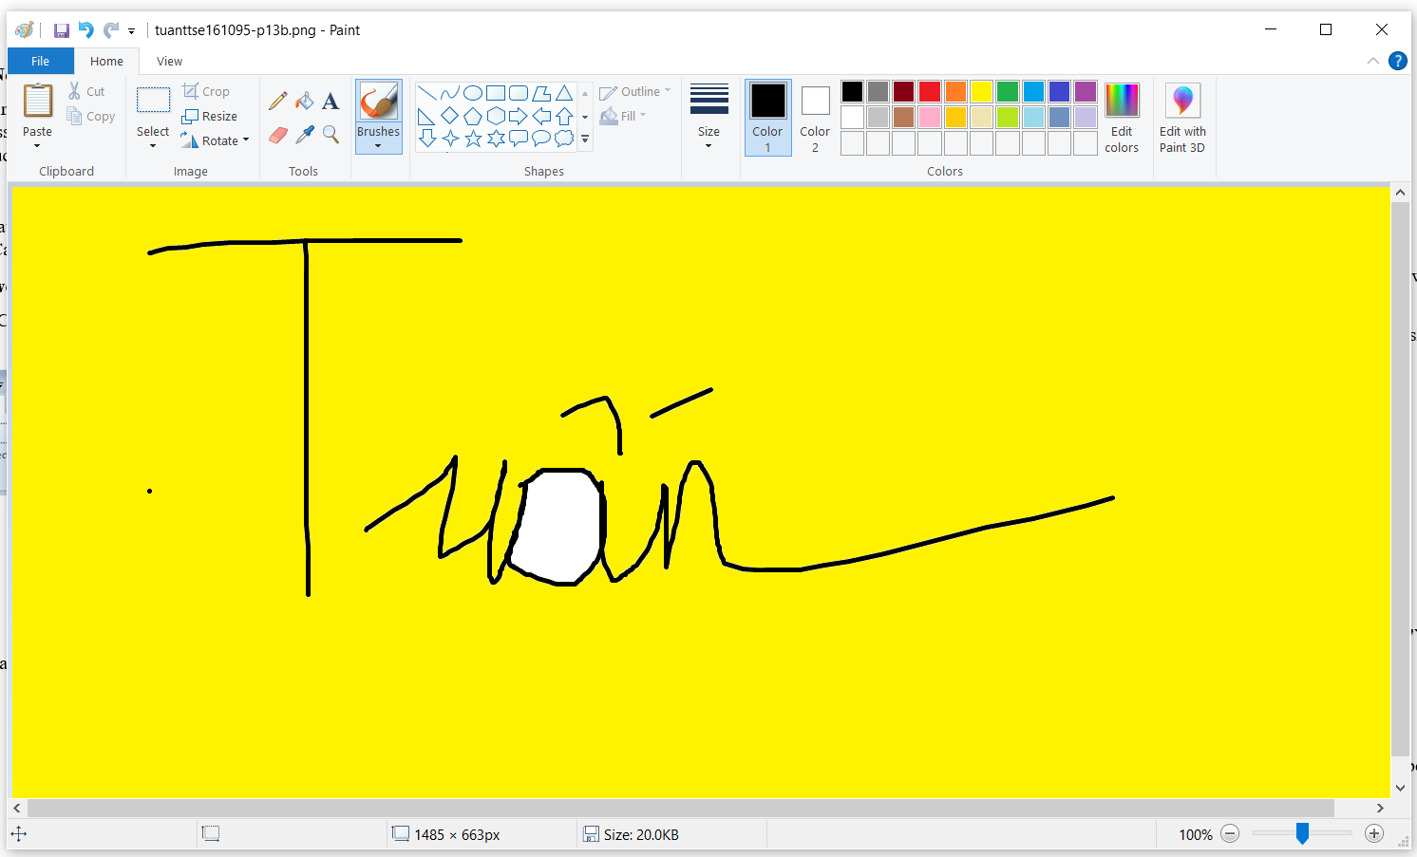

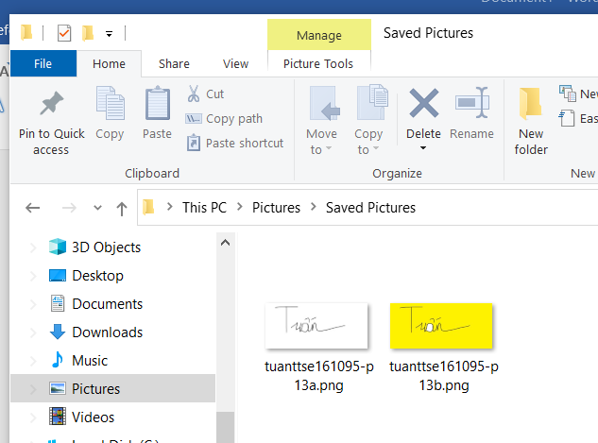

***Empty recycle bin***

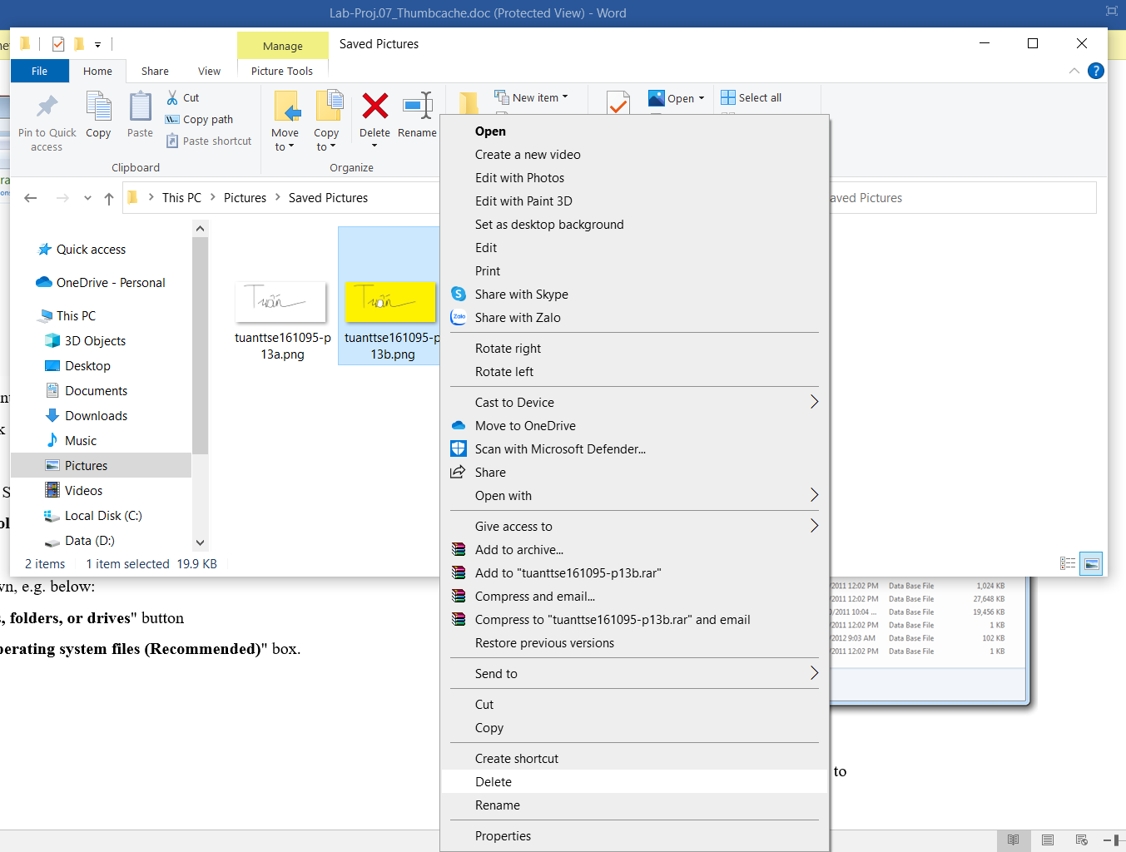

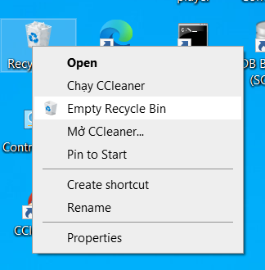

***Viewing the Thumbcache Files***

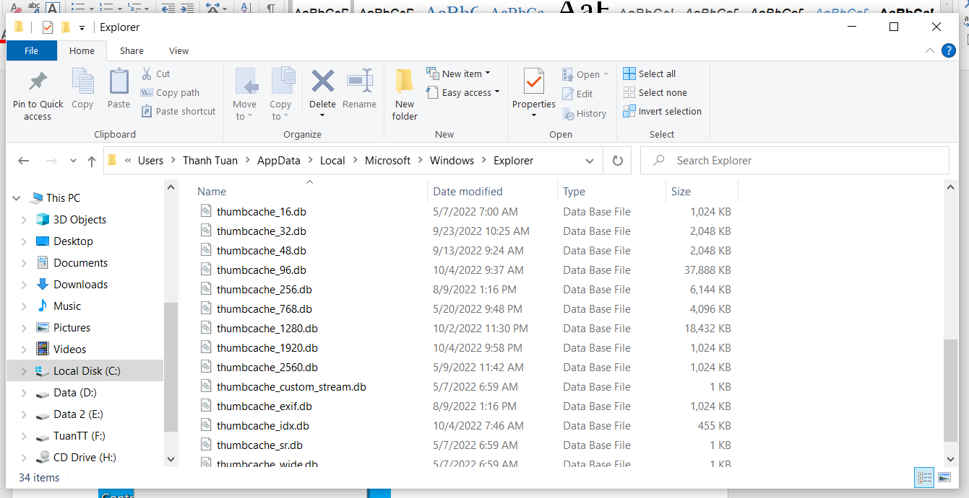

***Getting Thumbcache Viewer***

